Aleksis Daugats

Exam project, winter 2025,  
Multimedia Design

Website solution for DishDelights

Supervisors:  
Morten Algy Bonderup.

Hand-in date:  
February 14, 2025

[URL to coded solution](https://justmangoo.github.io/dishdelights/) [URL to GitHub repository](https://github.com/JustMangoo/dishdelights)

# Introduction

The DishDelights Recipe Website is a responsive web application designed to help users discover and manage recipes. Built using React and Vite, the website features a clean and intuitive user interface, client-side routing, and persistent data storage using localStorage. This report outlines the coding process, including front-end development, state management, routing, and responsive design.

# Programming

## Front-End Development

The front-end of the DishDelights website was built using React and CSS Modules for styling. The application is structured into reusable components, ensuring modularity and maintainability.

### Components:

* Header.jsx: Contains the navigation bar with a burger menu for mobile devices.
* Footer.jsx: Displays the copyright notice and company information.
* RecipeList.jsx: Renders a list of recipes with filtering and search functionality.
* RecipeDetail.jsx: Displays detailed information about a selected recipe.
* RecipeForm.jsx: Provides a form for adding or editing recipes.

### Styling:

* CSS Modules were used to scope styles to individual components, preventing conflicts.
* Media queries were implemented to ensure the website is responsive across devices.

## State Management

State management was handled using React's useState and useEffect hooks.

**useState:**

Managed local state for the selected recipe, form data, and menu toggle.

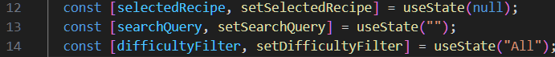

**useEffect:**

Used to load and save data to localStorage.

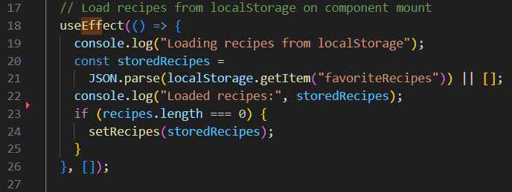

## Routing and Navigation

Client-side routing was implemented using React Router DOM.

**Routing Setup**

Routes were defined in App.jsx using createBrowserRouter.

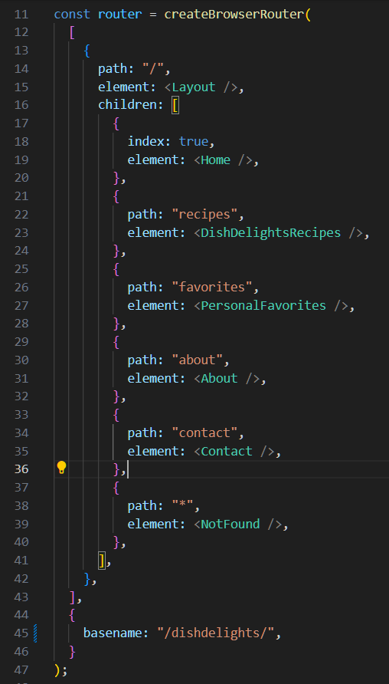

**Navigation**

The Header.jsx component uses Link from react-router-dom for navigation.

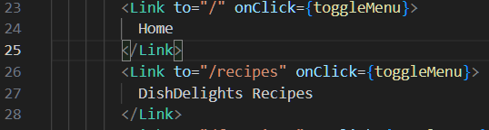

## Responsive Design

The website was designed to be fully responsive, with a desktop-first approach.

**Burger Menu**

A burger menu was implemented for mobile devices, toggling the visibility of navigation links.

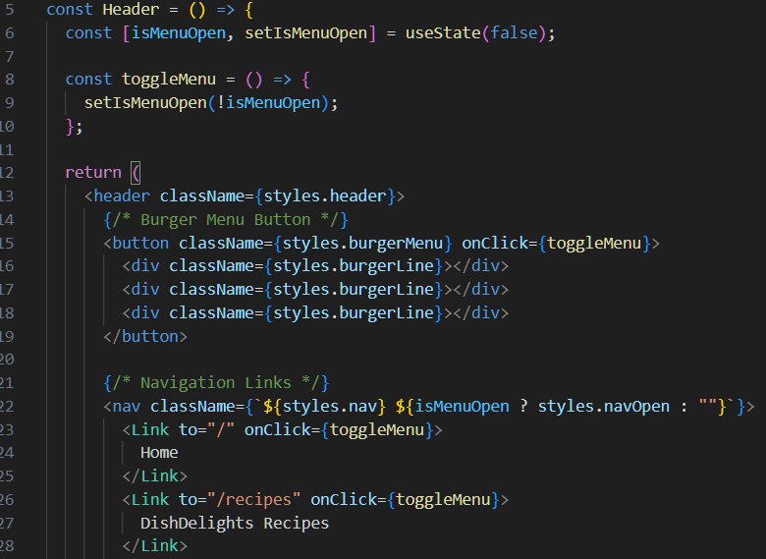

**Media Queries**

CSS media queries were used to adjust the layout for different screen sizes.

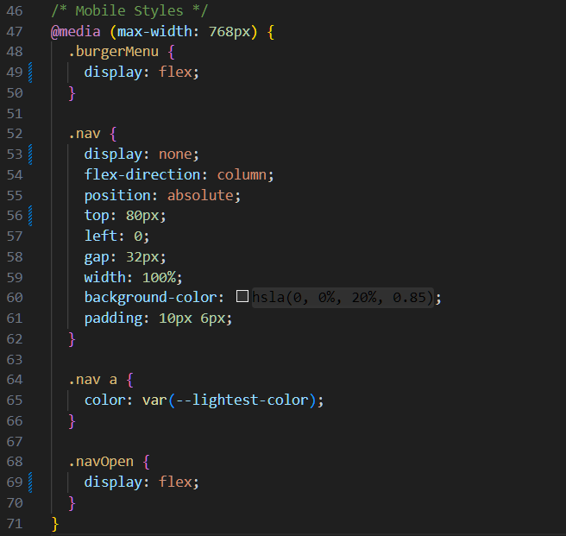

## Local Storage Integration

Personal favorite recipes were stored in localStorage to persist data across page reloads.

**Saving Data**

Recipes were saved to localStorage whenever the recipes state changed.

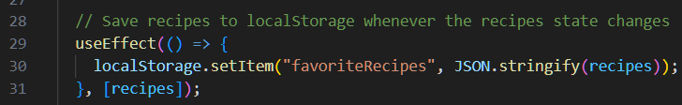

**Loading Data**

Recipes were loaded from localStorage when the component mounted.

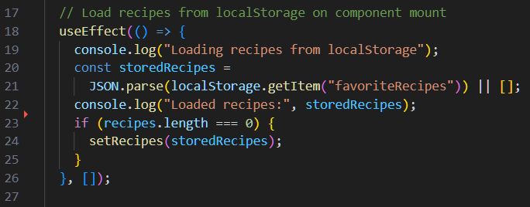

# Sources

### Technical Resources

* **React Documentation:** <https://react.dev/learn>
* **CSS Modules Documentation:** <https://github.com/css-modules/css-modules>
* **Google Fonts and Icons:** <https://fonts.google.com/>